**MedCord**

MedCord is a healthcare record and appointment keeping app that's disrupting the healthcare sector. We're focusing on making medical records of people around the world globally available and also make sure Doctors and clinical appointments are attended to.

# The team

Our diverse team comes from the Ladoke Akintola University of Technology, Ogbomoso, cultivated from two different faculties, Our team consists of two members, Adeniji Oluwaferanmi from the Faculty of Agricultural Science, Faith Morebise from the Faculty of Basic Medical Sciences.

Bringing a powerhouse team involving Entrepreneurship, Healthcare, Computer Science and backed by our supporting students from different faculties to Imagine Cup; we believe that we will be able to convince the judges, and the public, that not only is accessing Medical Records a significant problem to resolve in society but that we are the best team to do it.

Earlier, We won an app challenge (Hackathon) organized by the Federal Ministry of Youths and Sports development in Fall 2020.

**Adeniji Oluwaferanmi -** He is a Software Engineer passionate about solving world problems with his technical skills, Oluwaferanmi has worked with different companies as a Frontend Engineer crafting beautiful user interfaces for products and web applications. He is currently using his technical skills to exciting technological advances than happen everyday at MoneyMie. In his free time, He plays video games.

Major : Biotechnology,

Ladoke Akintola University of Technology.

Graduation Year : November 2021.

**Morebise Faith –** She isa Medical Laboratory science student focusing on developing Medical Analytical and diagnostic. In her free time, She reads novels and research papers.

**Major :** Medical Laboratory Science ,

Ladoke Akintola University of Technology.

Graduation Year: November 2021

**Mentors:**

* Dr Yemi Aderinto

He's well respected in his field and has given MedCord many insights into operations, business strategy, Having many connections to many different incubators and important figureheads in the startup circle in Nigeria, He lends us insight into how we can become a more socially impacting business and how we might integrate with the existing social enterprise climate in Nigeria.

# The Concept

With over 3 million cases of COVID-19 and sadly over 200,000 deaths.COVID-19 is no doubt ravaging the world and It's affecting humanity in various different ways.Unfortunately, most deaths come from people with underlying illnesses like diabetes,hypertension e.t.c. However,in some cases infected people with underlying heart conditions are treated with drugs that worsen their conditions because the physician has no prior knowledge of the underlying conditions.

**What are the identified problems?**

* Unavailability of patients medical records in emergency treatment centers
* In cases where the records are available,pulling or searching for this records are cumbersome,tedious and time-consuming
* Patients forget their doctors appointment

Solutions MedCord app is proferring:

* Record keeping:

Medcord solves the problem of having to search hospital records manually which might be time consuming, tedious and difficult by providing a platform where medical records can be accessed using patient’s mobile number or email address. We’ll be using Microsoft's Optical Character Recognition and Azure speech to text to add a voice controlled feature.

* Clinical appointment

The MedCord app will help remind patients when their appointment meetings are due by sending emails, notifications and SMS as well as informing doctors of the patients decision appointment.

## Target Audience or Market:

The target audience for this app are patients and Medical practictioners that want to explore a faster, more efficient way of accessing medical records of patients anywhere and anytime.

### Personas

### Medical Doctors

Doctors register through the Doctor's registration platform which takes their personal details, area of specialization, work experience, and Identity Cards.

With our existing Doctor's verification framework using Microsoft's Optical Character Recognition, we can verify a doctor.

Doctors can check records of registered patients using the patients issued ID or the phone number, Doctors can also add records to the retrieved patient's record.

* Patients

Patients register with their personal data which includes basic medical data (Genotype, Blood Group). These records are saved and can be accessed anywhere, anytime by a verified registered Doctor.

Records belonging to a patient also shows on the patient's dashboard,

Notifications from Doctor's appointment, Doctor's comments, and reviews also show on the patient's dashboard.

## Feedback

We introduced the demo app to few individuals, and we had some feedbacks.

* An individual was concerned about data credibility on the part of the patient , In essence , the individual was interested in knowing how patient’s record is being uploaded on the app.

We assured him that patients are not permitted to upload or make changes to their records.

* An individual asked about the process of verifying doctors on the platform.

We reinstate our commitment in keeping MedCord safe and secured for users, by pointing out

the different verification processes Doctor’s go through before being approved to check patient’s record.

Both individuals were satisfied with our response and they opened an account on MedCord.

# How it works:

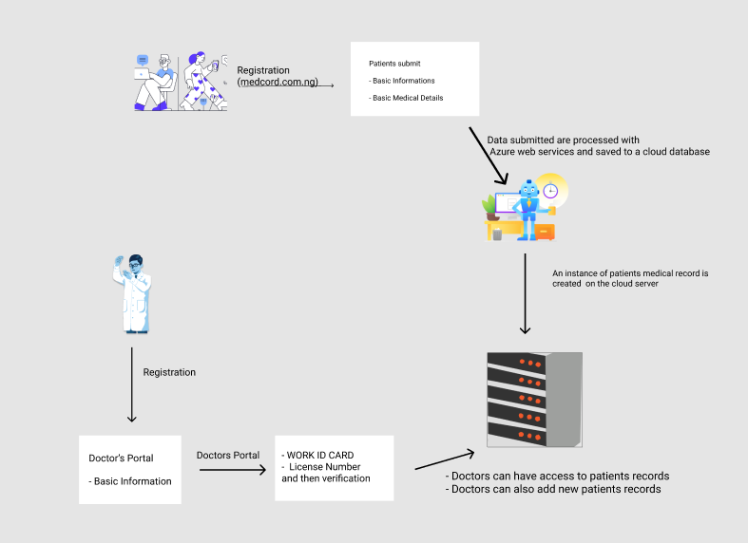

There are two sections to the app, the patients and the doctors portal.

Records can be accessed and edited from the app by a verified medical doctor using the patients phone number or email address. Those records include medical history of the patients, last symptoms, last diagnosis and treatments.

User records are safely kept in a cloud hosted data storage and also made available over Content Delivery networks to ensure faster and optimized delivery of the app assets. Using Azure cloud storage , MedCord is able to also serve users in low network area.

Using the Azure Face Recognition Service, Doctor’s can access patients record by simply capturing patients face.

## Core Technologies

* Microsoft's Optical Character Recognition
* Azure Speech to text Service
* Azure Face Recognition Service

# The Business Plan:

## **- Premium Plan**

## As we grow,We plan to introduce A premium version of the app.

## The premium plan would be paid and would have unlimited access to all of our products.

## **- Ads**

## We plan to show paid medical advertisements tailored to the needs of our users from Google .

## We would be able to drive out income from the impressions of the advertisements we show.

## Competition:

Competitive Advantage:

We are sure to beat our competitors because of:

* The tons of integrations our product have
* The pricing model is affordable. Huge Market size
* Easy product accessibility
* Simple and minimal product interface design for ease and convenience

## Business Model

MedCord makes money in two ways: With Premium Version, they get access to advanced features from the app.   
Also, We’ll partner with Google Adsense to serve ads to users which will in turn generate revenue.

# Additional Information:

Website Link : https://medcord.com.ng